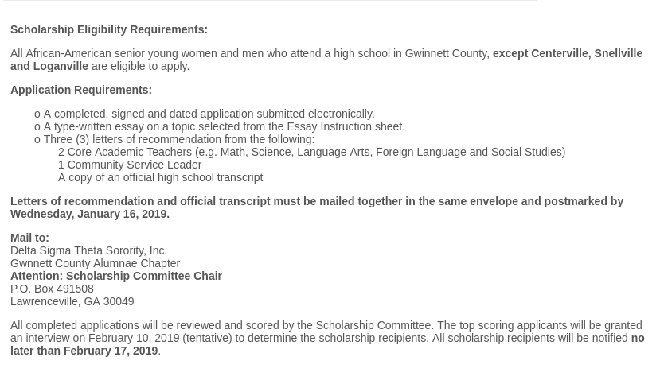

Read and Understand the instructions.
Yes, I have read and understand the college scholarship eligibility requirements.

Student's Name

First Name Middle Name Last Name
o

Home Address :

Street Address

Street Address Line 2

City State / Province

Postal / Zip Code

Home Telephone Number
: _{Area}
Code
Cell Number :
Area Code
E-mail :

Parent/Guardian Name(s)

Name of High School

School Address

Phone Number

Phone Number

1)

2)

3)
Street Address

Street Address Line 2

City State / Province

Postal / Zip Code

1. List honors and awards:

2. List extracurricular activities - organizations and clubs (Indicate years of involvement and any offices held:

3. Please provide a brief description of your community service activites (Indicate years of involvement and/or period of service

Counselor's Name

Counselor's E-mail

College entrance examination score
ACT
SAT

Highest ACT Composite Score:

Highest SAT Math Score:Highest SAT Verbal Score:

Cumulative High School grade point average (GPA):
m
m

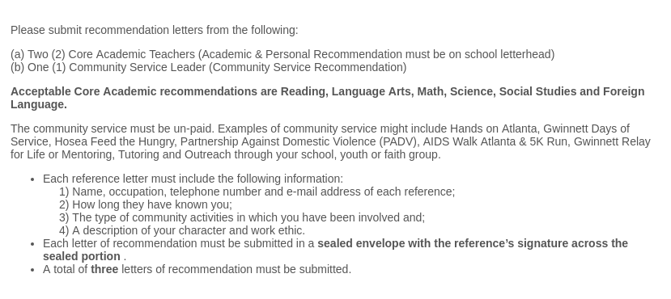
Class Rank NumberClass

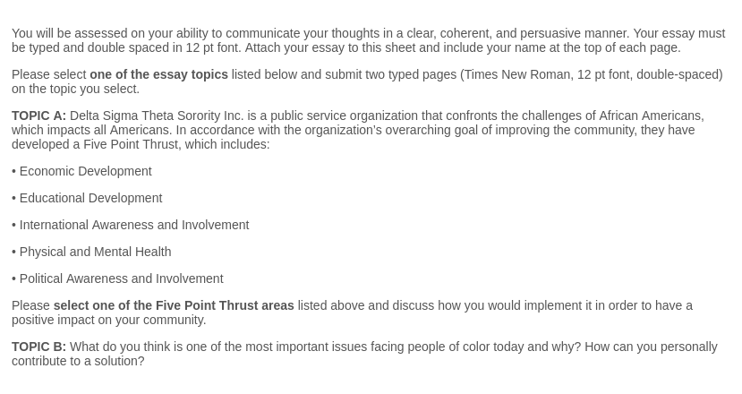

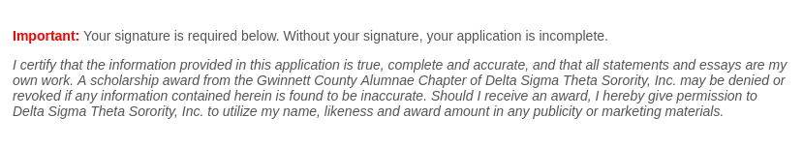
Essay:

Name of Applicant

First Name Last Name

Applicant E-Signature:

Name of Parent/Guardian

First Name Last Name

Parent/Guardian E-Signature:

Date
MonthDay Year
Submit Form
Powered by TCPDF (www.tcpdf.org)

